

otaku store

* **Faculty: Ho Hoan Kiem**
* **Batch:**
* **Team Member:**
  + - * **ĐẶNG VĂN HOÀNG**
      * **ĐỔNG QUANG HUY**
      * **BÙI QUANG HUY**

**Ho Chi Minh City, Feb 4 2018**

Table of Contents

1. Review 1

* **Problem Definition..…………………………………………………………………………………01**
* **Customer Request Specification……………………………………………………………… 02**

1. Review 2

* ***Use Case Diagram* 04**
* ***Class Diagram* 15**
* ***Sequence Diagram* 16**
* ***ERD* 18**
* ***Entity Description* 19**
* ***Table Relationship Diagram* 26**

1. Review 3

* Interface Design………………………………………………………………………………..... 27
* Site Map……………………………………………………………………………………………… 51
* Report ………………………………………………………………………………………………..53
* Tasksheet……………………………………………………………………………………………. 56

REVIEW 1

Problem Definition

1. **The Object Of The Project**

This project will create a shopping figure store website. This will be accessible to all users who visit this store. This system provides the following facilities:

* Viewing the product information and find product easier.
* Supporting check outproduct for authorized user or guest.
* Create a blog for support user to buy figure with more benifits from expert experience.
* Supporting user by contact page, when users have problem they can contact with admin by sending message.
* Helping user to register an account when they don’t have.

***Customer Request***  
 Specification

1. **Functional Requirements**

**For Users :**

* The user can check out figures without login or login.
* User will able to request a login when they want to check out the product or add some products into wishlist.
* If User does not have an account, they can register for new account.
* If user forgetstheir account, they can get their password by confirm code in their email.
* If user is authorized, they will take a formand must fill in some nessecary information before order.
* The product that user added to theirwishlist. It will be send the message when this product is changed status,information orsale off price.
* The authorized user canshow theirattention below the product by comment,rating.
* The user cancontact to admin when they have a trouble.
* The user can view blog or FAQ to get more information about product or news.
* The user can search products by keyword, brand, manufacturer or series anime.

**For Admin :**

* Admin can manage products includes: Insert, edit, delete (set IsDelete) action.
* Admin can block user.
* Admin can manage blogs and FAQ includes: Insert, edit, delete (set IsHidden) action.
* Admin can check user’s message.

# Hardware/ Software Requirements

By adding new technologies such as ASP.NET 4.0, MVC5 Framework, AJAX, Web Service and 3-tier architecture, the web site becomes more interactive with users, security and easily updated.

1. **System Requirement**

* **For Users**
  + **Hardware**
    - CPU: Pentium IV 2.0 GHz or higher
    - RAM: 512 MB or higher
  + **Software**
    - OS: Windows10/Windows 7/
    - Browser: Chrome/Fire Fox/Internet Explorer 8.0 or higher
* **For Software Developers**
  + **Hardware**
    - CPU: Pentium IV 2.0 GHz or higher
    - RAM: 512 MB or higher
  + **Software**
    - OS: Windows 10 / Windows 7
    - Environment: Microsoft .NET 4.0 or higher
    - Database Management System: Microsoft SQL Server 2017
    - IDE: Microsoft Visual Studio 2017
    - Web Server: Internet Information Services (IIS) JSP / Servlets Dev. Kit
    - Frond-end Libraries: Bootraps, Jquery, Owl.casourel.js,…..

|  |  |  |
| --- | --- | --- |
| **Date: Sep 10, 2012** | **Prepared by Project Group 4**  **Team Leader:** | **Approved by**  **Mr Ho Hoan Kiem** |
| **Signature** |  |  |

REVIEW 2

**USE CASE DIAGRAM**

**Overview:**

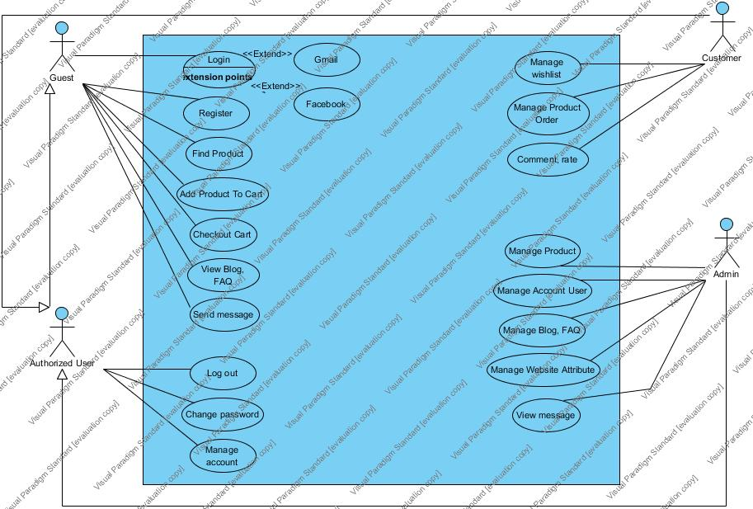

**Guest:**

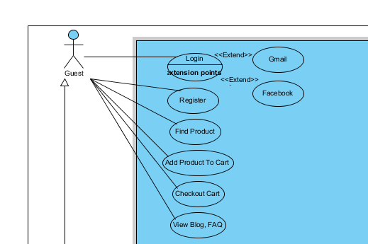

**Authorized User:**

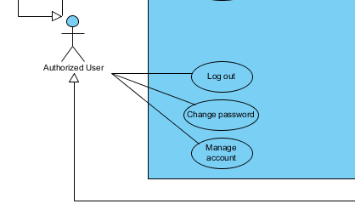

**Customer:**

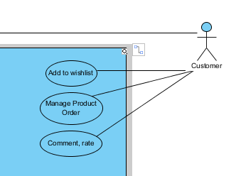

**Administrators :**

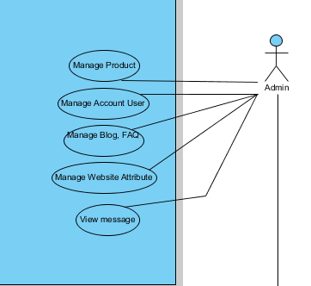

**USE CASE DESCRIPTION**

1. **Actor:**

* **Guest**: include all visitors that use this website. ***Guest*** is a person who uses this website but doesn’t register.
* **Authorized User**: include all visitors that use this website. ***Authorized*** user is a person who logined into website but services does not authorize that user to be ***Customer*** or ***Admin***
* **Customer:** include all visitors that use this website. They are guests and members.***Customer*** is a person who uses this website and register to become a member of us. When be a ***Customer****,* they will have more benefits but Guest does not.
* **Website administrator:** The person(s) who manage products, users, blogs, FAQ, message, orders and maintain this web site.

1. **Usecase Description:**

**Guest:**

|  |  |
| --- | --- |
| **Usecase** | Register |
| **Short Description** | Register account to become a member of the web site. |
| **Pre-Conditions** |  |
| **Post-Conditions** | Have an account |
| **Main flow** | _Guest must provide mandatory information :   * Email * Password. * Confirm Password.   _Guest clicks on Register button.  _System checks the information which guest provided  _System create new account for guest that registers to this website.  _Guest becomes a member of this website. |
| **Alternative flow(s)** | _If the mandatory information that guest provided, is missed or not exactly, system notifys the error. All cases are :   * Password is less than 6 characters or more than 30 characters. * Confirm Password and Password are not the same. * Email is invalid or has existed in database. * Any fields are blank.   _System mustcreate the date that guest register to become member.  _If server notifys any error when it’s processing, system must be write report into Log file. |

|  |  |
| --- | --- |
| **Usecase** | Login |
| **Short Description** | Log in website to use any function of member. |
| **Pre-Conditions** | User must not login another account |
| **Post-Conditions** |  |
| **Main flow** | _Guest inputs the login information :   * Login ID. * Password.   _Guest clicks on the Login button.  _System check the Login ID and Password.  _If Login ID and Password are valid, system will move member to Homepage. |
| **Alternative flow(s)** | _If guest clicks on “Reset” button, the Login ID field and Password field are blank.  _If Login ID field or Password field is invalid form or blank when guest clicks on the “Login” button, system will notify the error.  _If server notifies any error when it’s processing, system must be write report into Log file. |

|  |  |
| --- | --- |
| **Usecase** | View detail Product (Guest) |
| **Short Description** | Read the detail Product on this website. |
| **Pre-Conditions** |  |
| **Post-Conditions** |  |
| **Main flow** | _user access the home page.  _userclick on name of product to access product detail page  _In this page, user can see all of product’s information includes: title, price, sale, status, description, rate and comment,…. |
| **Alternative flow(s)** | _If server notifies any error when it’s processing, system must be write report into Log file. |

|  |  |
| --- | --- |
| **Usecase** | Check out(Guest) |
| **Short Description** | Check out the product without login |
| **Pre-Conditions** | Cart must have at least one product. |
| **Post-Conditions** | Guest will be taken a code order. |
| **Main flow** | _Guest input check out information:   * Name: * Address: * Phone number: * Note:   _Guest click on the check out button  _If the check out information is valid, system will notice that successed and move guest to home page.  _If the check out information is invalid, system will notice the line that invalid information. |
| **Alternative flow(s)** | _If any information edit are invalid, system will notify the error.  _If server notifies any error when it’s processing, system must be write report into Log file. |

|  |  |
| --- | --- |
| **Usecase** | Search (Guest) |
| **Short Description** | Search the product by keyword, tags and manufactors. |
| **Pre-Conditions** |  |
| **Post-Conditions** | Show all product matched with keywords, tags,manufactors. |
| **Main flow** | _Useraccess home page  _User input any keywords in searching field or click any category field  _System move guest to search page. |
| **Alternative flow(s)** | _If server notifies any error when it’s processing, system must be write report into Log file. |

|  |  |
| --- | --- |
| **Usecase** | Contact by sending message to website (Guest) |
| **Short Description** | Contact with website by sending a message |
| **Pre-Conditions** | User must fill in all necessary information before send message. |
| **Post-Conditions** | User’s message will be update in database. |
| **Main flow** | _When user click on Contact Page, system will show all information about website and below it will have a form to contact with website.  _User can send any problem about figure, shiping, order,… by this form.  _When user fill in all necessary information, system will send a successful message to user and move them to home page. |
| **Alternative flow(s)** | _If any information input are invalid, system will notify error message.  _If server notifies any error when it’s processing, system must be write report into Log file. |

**Customer:**

|  |  |
| --- | --- |
| **Usecase** | Change password |
| **Short Description** | User can change their password. |
| **Pre-Conditions** |  |
| **Post-Conditions** |  |
| **Main flow** | _User can change their password by 2 ways:   * By email confirm. * By old password.   _If user click change password by email, system will send them a link in their email and they much click on that to change password.  _If user click change password by old password, system will show a form. In that form, user must fill in old password and new password.  _System check old password and new password is valid.  _If all are valid, system will move member to Homepage and update their password in database |
| **Alternative flow(s)** | _If any field is invalid form or blank, system will notify the error.  _If server notifies any error when it’s processing, system must be write report into Log file. |

|  |  |
| --- | --- |
| **Usecase** | Logout |
| **Short Description** | Clear all information that login on the website. |
| **Pre-Conditions** | User must logined into website first. |
| **Post-Conditions** |  |
| **Main flow** | _ Clear all session and information of account that login into the website.  _System will move guest to home page without login account |
| **Alternative flow(s)** | _If server notifies any error when it’s processing, system must be write report into Log file. |

|  |  |
| --- | --- |
| **Usecase** | Manage wishlist(Customer) |
| **Short Description** | Add or removeproduct from wishlist. |
| **Pre-Conditions** | User must login into website first. |
| **Post-Conditions** | That product will add into wishlist or remove out wishlist |
| **Main flow** | _Customer access in the view product detail page  _ Customer clicks button “add to wish list”.  _System will load for 1 second to notify user that system is working.  _After 1 second, wishlist on search main will update quantity product in wishlist.  _ Customer also can click again button “added” to remove that product out wishlist. |
| **Alternative flow(s)** | _If server notifies any error when it’s processing, system must be write report into Log file. |

|  |  |
| --- | --- |
| **Usecase** | Check Out(Customer) |
| **Short Description** | Check outcart with authorized customer. |
| **Pre-Conditions** | Cart must have at least one product. |
| **Post-Conditions** | All products in cart will be excuted in database. |
| **Main flow** | _Customer choose cart and click “check out” button to checkout  _System will fill in allnecessary information of check outform by personal information of customer.  _System will notice successful message to customer.  _System will move user to home page. |
| **Alternative flow(s)** | _If server notifies any error when it’s processing, system must be write report into Log file.  _During check out processing is excuting, if something wrong happen, system will show an error message to customer. |

|  |  |
| --- | --- |
| **Usecase** | Comment,Rate Product (Customer) |
| **Short Description** | Comment,rate product by user |
| **Pre-Conditions** | User must login into website first. |
| **Post-Conditions** | Their comment and rate will be shown on product. |
| **Main flow** | _When customer view detail of product, they can comment and rate below the product.  _System will reload the detail product for updating if customer comment and rate successful. |
| **Alternative flow(s)** | _If server notifys any error when it’s processing, system must be write report into Log file. |

|  |  |
| --- | --- |
| **Usecase** | View/edit profile (Customer) |
| **Short Description** | Manage personal profile of user. |
| **Pre-Conditions** | User must login into website first. |
| **Post-Conditions** | Personal profile of customer will be updated. |
| **Main flow** | _customer can edit the personal profile.  _System will edit customer’s information in database and update it.  _After edit successful, system will reload page and notify a successful message to customer. |
| **Alternative flow(s)** | _If any information edit are invalid, system will notify error message.  _If server notifies any error when it’s processing, system must be write report into Log file. |

**Admin:**

|  |  |
| --- | --- |
| **Usecase** | Manage Product (Admin) |
| **Short Description** | Manage all Products includes: insert, edit, delete (set isDeleted) |
| **Pre-Conditions** | User must login into website with authorizationis administrator. |
| **Post-Conditions** | All of product’s information will be updated in database. |
| **Main flow** | _After click “product management” tab, system will show all products in a table for admin.  _Admin can insert, edit or set isDeleted status foreach product from admin page.  _When Admin insert, edit or set isDeleted status successful, system will send a message to admin and move that admin to manage product page. |
| **Alternative flow(s)** | _ If any information edit are invalid, system will notify the error.  _If server notifies any error when it’s processing, system must be write report into Log file. |

|  |  |
| --- | --- |
| **Usecase** | Manage Account user (Admin) |
| **Short Description** | Manage all account user, Admin also can block user. |
| **Pre-Conditions** | Must be logined into website with authorized is admin |
| **Post-Conditions** |  |
| **Main flow** | _Admin chooses an accountthat administrator wants to see information.  _Admin also can block user immediately |
| **Alternative flow(s)** | _If server notifies any error when it’s processing, system must be write report into Log file. |

|  |  |
| --- | --- |
| **Usecase** | Manage Website Attributes (Admin) |
| **Short Description** | Manage all website attributes. |
| **Pre-Conditions** | Must be logined into website with authorized is admin |
| **Post-Conditions** | Website attributes will be updated when something changed. |
| **Main flow** | _If “Website attribute info” page isloaded, system will show all attributes of website to admin.  _Admin also can change any attribute.  _If any attribute has changed, system will update in database and reload page for admin. |
| **Alternative flow(s)** | _If server notifies any error when it’s processing, system must be write report into Log file. |

|  |  |
| --- | --- |
| **Usecase** | Manage Blog, FAQ (Admin) |
| **Short Description** | Manage all blog, FAQ (add, edit, delete). |
| **Pre-Conditions** | Must be logined into website with authorized is admin |
| **Post-Conditions** |  |
| **Main flow** | _If “Blog Management” or “FAQ Management” page is loaded, system will show all blogs or FAQ to admin.  _Administrator chooses any blog, FAQ that administrator wants to see more detail information.  _Administrator also can add, edit or set hidden for each blog or FAQ. |
| **Alternative flow(s)** | _If server notifies any error when it’s processing, system must be write report into Log file. |

|  |  |
| --- | --- |
| **Usecase** | Manage Message Sending(Admin) |
| **Short Description** | Manage all messages sending from users. |
| **Pre-Conditions** | Must be logined into website with authorized is admin |
| **Post-Conditions** |  |
| **Main flow** | _If “Inbox” page is loaded, system will show message from user to admin.  _Admin just only see their message. |
| **Alternative flow(s)** | _If server notifies any error when it’s processing, system must be write report into Log file. |

**CLASS DIAGRAM**

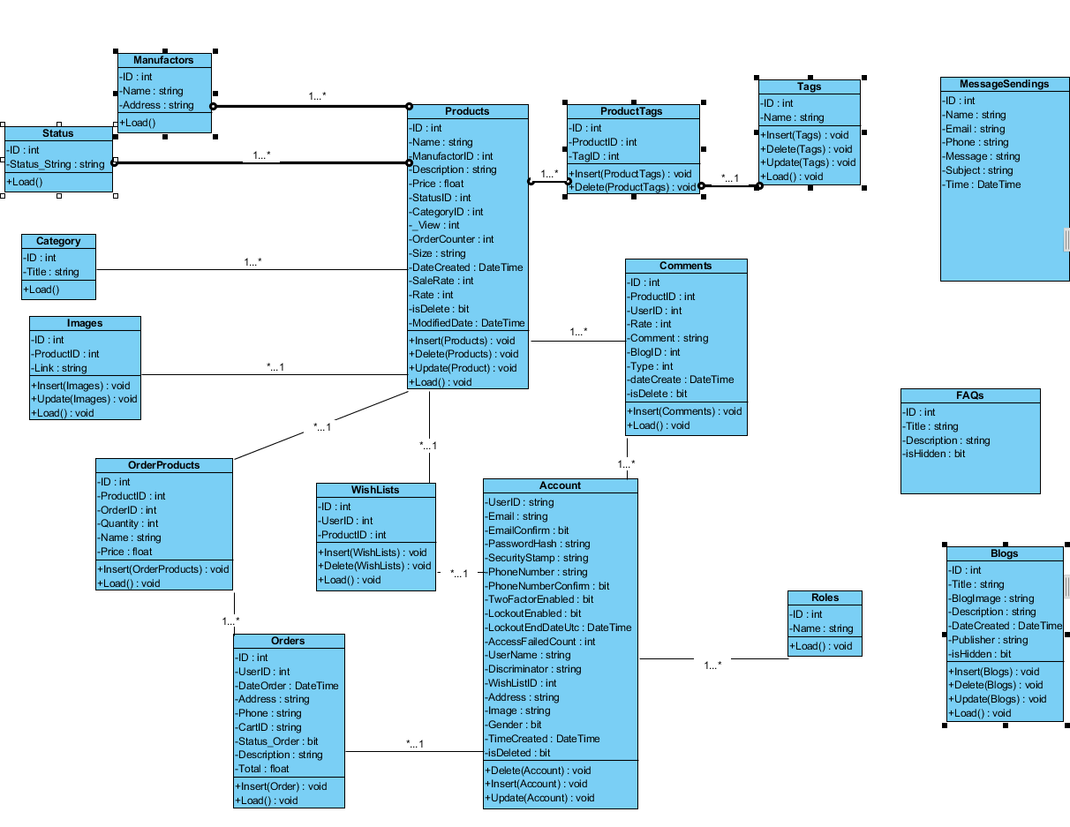

**ENTITY RELATIONSHIP DIAGRAM (ERD)  
  
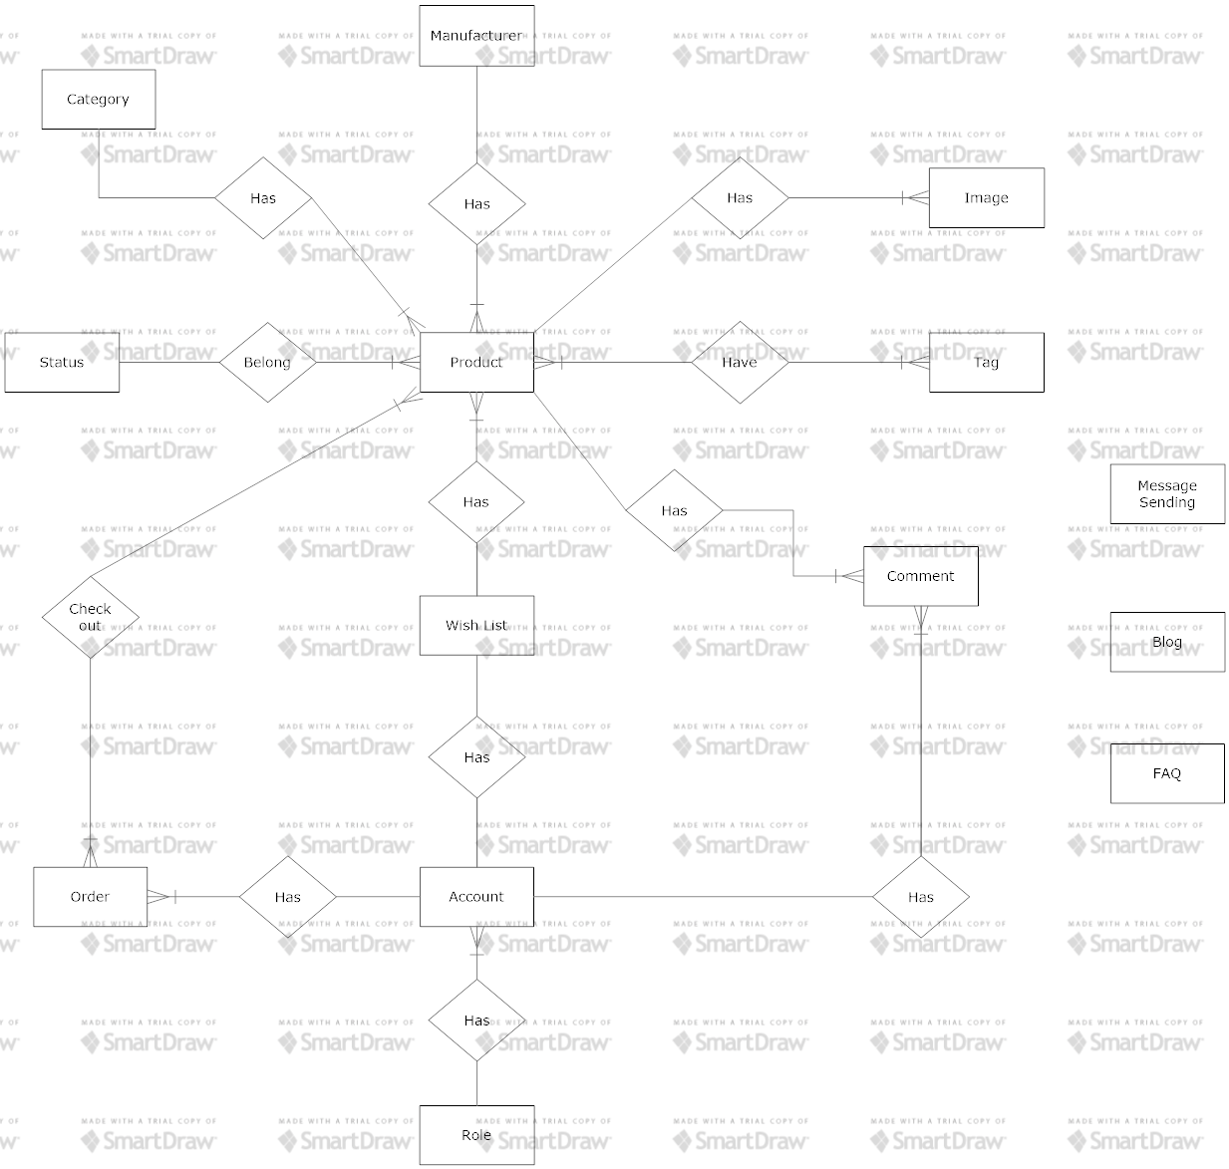**  
 **Note:  
  
  
ENTITY DESCRIPTION**

Entity

Entity Relationship

One to  
 many relationship

**1.Account Customer :**

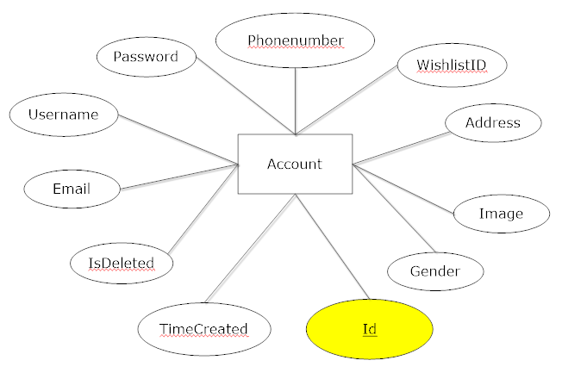 **2.Manufacturer :**

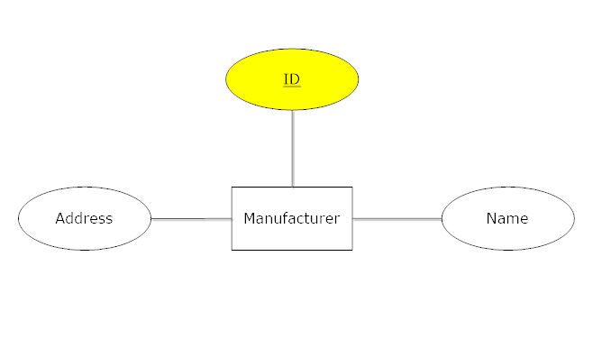 **3.Status :**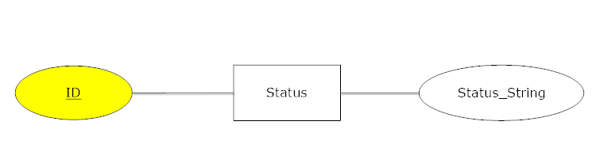

**4.Category: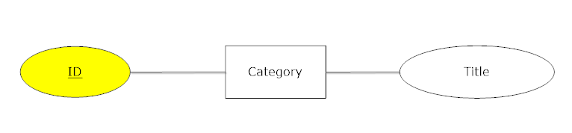 5.Image :**

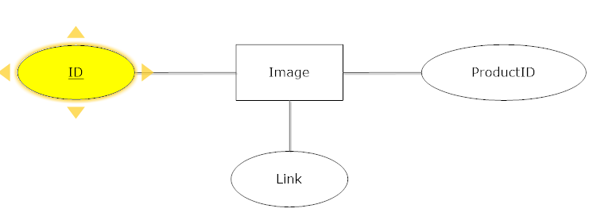

**6.Product :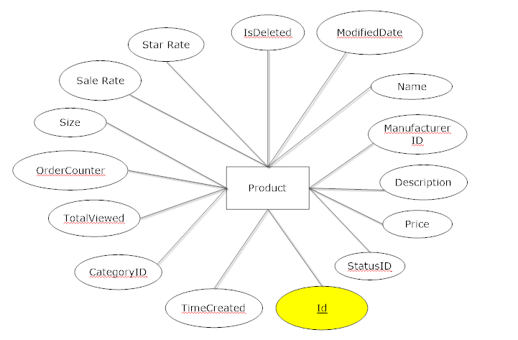 7.Tag :**

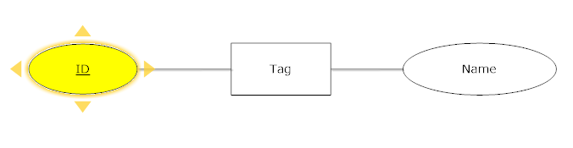**8.Role:**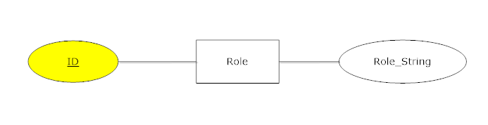

**9.Comment :**

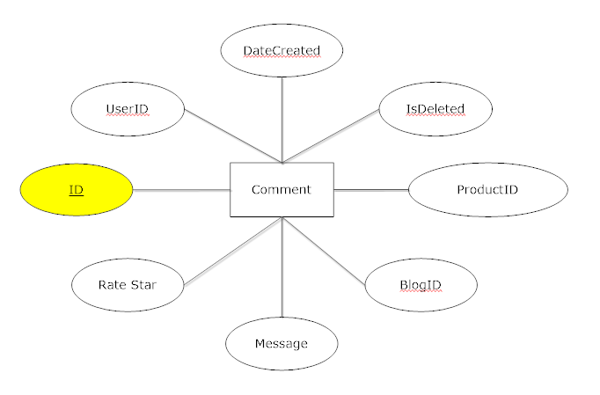

**10.Wishlist:**

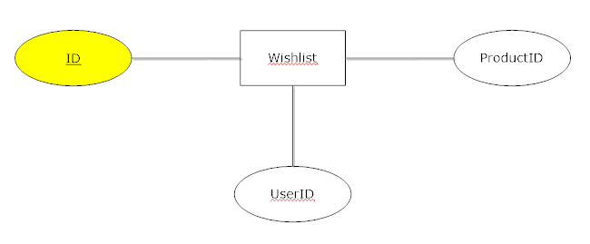

**11.Order:**

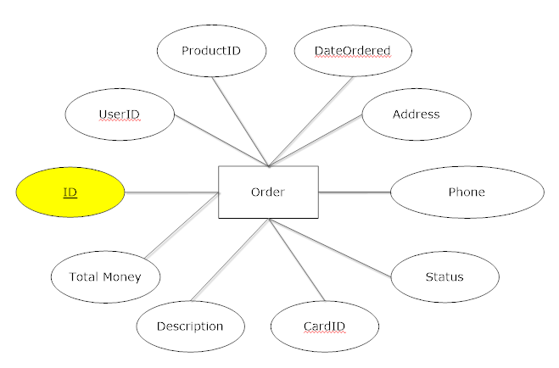

**12.Message Sending:**

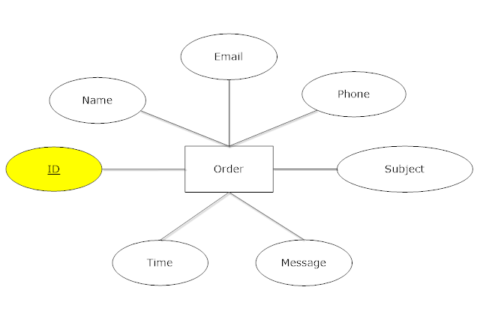

**13.FAQ:**

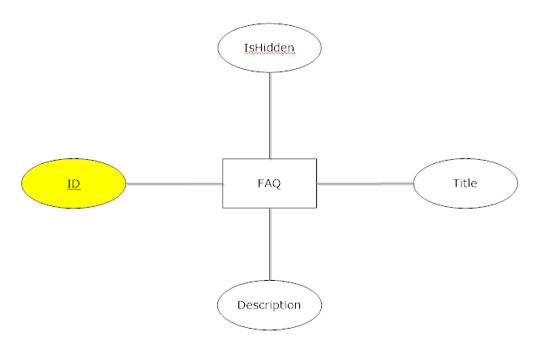

**14.Blog:**

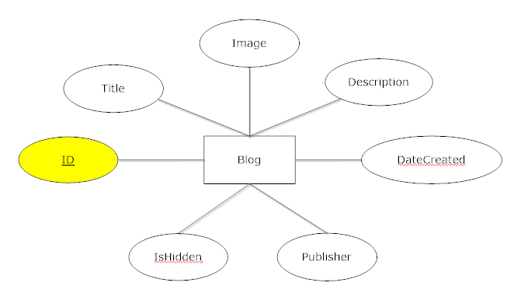

**TABLE DESIGN**

1. **Accounts :**

|  |  |  |  |  |  |
| --- | --- | --- | --- | --- | --- |
| **No** | **Column Name** | **Data Type** | **Size** | **Check** | **Description** |
| 1 | **🗝**UserId | Varchar | 128 | Not Null | Account’s ID |
| 2 | ✓Email | Varchar | 255 | Not Null | Account’sEmail |
| 3 | EmailConfirmed | Bit |  | Not Null | Account’sEmailConfirmed |
| 4 | PasswordHash | Varchar | 255 | Not Null | Account’s Password is converted to hashCode |
| 5 | SecurityStamp | Varchar | 255 | Null | Account’s SecurityStamp tracking changes of profile |
| 6 | PhoneNumber | Varchar | 255 | Null | Account’s PhoneNumber |
| 7 | PhoneNumberConfirmed | Bit |  | Null | Account’s PhoneNumberConfirmed |
| 8 | TwoFactorEnabled | Bit |  | Null | Account’s TwoFactorEnabled is enable another login(Phone,Email) |
| 9 | LockoutEnabled | Bit |  | Null | Account’s LockoutEnabled |
| 10 | LockoutEndDateUtc | Datetime |  | Null | Account’s LockoutEndDateUtc |
| 11 | AccessFailedCount | Int |  | Not Null | Account’s AccessFailedCount |
| 12 | ✓UserName | Varchar | 255 | Not Null | Account’s UserName |
| 13 | Discriminator | Varchar | 128 | Not Null | For creating application role |
| 14 | WishlistID | Int |  | Null | Account’s WishlistIDs |
| 15 | Address | Varchar | 255 | Null | Account’s Address |
| 16 | Image | Varchar | 255 | Null | Account’s Image Link |
| 17 | Gender | Bit |  | Not Null | Account’s Gender |
| 18 | TimeCreated | Datetime |  | Null | Account’s TimeCreated |
| 19 | Status | Bit |  | Null | Account’s Priority when order |
| 20 | Total | Float |  | Null | Account’s Total Order money |
| 21 | isDelete | Bit |  | Not Null | Account’s isDelete |

1. **UserRoles:**

|  |  |  |  |  |  |
| --- | --- | --- | --- | --- | --- |
| **No** | **Column Name** | **Data Type** | **Size** | **Check** | **Description** |
| 1 | **🗝**UserId | Varchar | 128 | Not Null,unique | UserID mapping |
| 2 | RoleId | Varchar | 128 | Not null | RoleID mapping |
| 3 | IdentityUser_Id | Varchar | 128 | Null | IdentityUser_Id |

1. **Roles:**

|  |  |  |  |  |  |
| --- | --- | --- | --- | --- | --- |
| **No** | **Column Name** | **Data Type** | **Size** | **Check** | **Description** |
| 1 | **🗝**Id | Varchar | 128 | Not Null | ID |
| 2 | Name | Varchar | 255 | Null | Name |
| 3 | UserRolesUserId | Varchar | 128 | Not Null | UserRolesUserId |

1. **WishLists:**

|  |  |  |  |  |  |
| --- | --- | --- | --- | --- | --- |
| **No** | **Column Name** | **Data Type** | **Size** | **Check** | **Description** |
| 1 | **🗝**Id | Int | 5 | Not Null | WishList’s ID |
| 2 | UserID | Varchar | 128 | Not Null | UserID mapping |
| 3 | ProductID | Int |  | Not null | Product mapping |

1. **Comments:**

|  |  |  |  |  |  |
| --- | --- | --- | --- | --- | --- |
| **No** | **Column Name** | **Data Type** | **Size** | **Check** | **Description** |
| 1 | **🗝** Id | Int |  | Not Null | Comment’s ID |
| 2 | ProductID | Int |  | Not Null | ProductID mapping |
| 3 | Rate | Int |  | Null | Comment’s Rate |
| 4 | dateCreate | Datetime |  | Not Null | Comment’s Datetime Created |
| 5 | isDelete | Bit |  | Not Null | Comment’s isDelete |

1. **Orders:**

|  |  |  |  |  |  |
| --- | --- | --- | --- | --- | --- |
| **No** | **Column Name** | **Data Type** | **Size** | **Check** | **Description** |
| 1 | **🗝**Id | Int |  | Not Null | Orders’s Id |
| 2 | UserID | Varchar | 128 | Not Null | UserID mapping |
| 3 | DateOrder | Datetime |  | Not Null | Orders’s DateOrder |
| 4 | Address | Varchar | 255 | Null | Orders’s Address |
| 5 | Phone | Varchar | 12 | Null | Orders’s Phone |
| 6 | CardID | Varchar | 20 | Null | Orders’s CardID |
| 7 | Status | Bit |  | Not Null | Orders’s Status |
| 8 | Description | Varchar | Max | Null | Orders’s Description |
| 9 | Total | Float |  | Null | Orders’sTotal |

1. **OrderProducts:**

|  |  |  |  |  |  |
| --- | --- | --- | --- | --- | --- |
| **No** | **Column Name** | **Data Type** | **Size** | **Check** | **Description** |
| 1 | **🗝**Id | Int |  | Not Null | OrderProducts’s ID |
| 2 | OrderID | Int |  | Not Null | OrderID mapping |
| 3 | ProductID | Int |  | Not Null | ProductID mapping |
| 4 | Quantity | Int |  | Not Null | OrderProducts’s Quantity |
| 5 | Name | Varchar | 255 | Not Null | OrderProducts’s Name |
| 6 | Price | Float |  | Not Null | OrderProducts’s Price |

1. **Products:**

|  |  |  |  |  |  |
| --- | --- | --- | --- | --- | --- |
| **No** | **Column Name** | **Data Type** | **Size** | **Check** | **Description** |
| 1 | **🗝**Id | Int |  | Not Null | Products’s ID |
| 2 | Name | Varchar | 255 | Not Null | Products’s Name |
| 3 | ManufactorID | Int |  | Not Null | Products’s ManufactorID |
| 4 | Description | Varchar | Max | Null | Products’s Description |
| 5 | Price | Float |  | Null | Products’s Price |
| 6 | StatusID | Int |  | Not Null | Products’s StatusID |
| 7 | CategoryID | Int |  | Not Null | Products’s CategoryID |
| 8 | _View | Int |  | Null | Products’s View |
| 9 | OrderCounter | Int |  | Null | Products’s OrderCounter |
| 10 | Size | Varchar | 255 | Null | Products’s Size |
| 11 | DateCreated | Datetime |  | Not Null | Products’s DateCreated |
| 12 | SaleRate | Int |  |  | Products’s SaleRate |
| 13 | Rate | Int |  | Null | Products’s Rate |
| 14 | isDelete | Bit |  | Not Null | Products’s isDelete |
| 15 | ModifiedDate | Datetime |  | Null | Products’s ModifiedDate |

1. **Manufactors:**

|  |  |  |  |  |  |
| --- | --- | --- | --- | --- | --- |
| **No** | **Column Name** | **Data Type** | **Size** | **Check** | **Description** |
| 1 | **🗝**Id | Int |  | Not Null | Id |
| 2 | Name | Varchar | 50 | Null | Name |
| 3 | Address | Varchar | 50 | Null | Address |

**10. Status:**

|  |  |  |  |  |  |
| --- | --- | --- | --- | --- | --- |
| **No** | **Column Name** | **Data Type** | **Size** | **Check** | **Description** |
| 1 | **🗝**Id | Int |  | Not Null | Id |
| 2 | Status_String | Varchar | 50 | Null | Status_String |

**11.ProductTags**

|  |  |  |  |  |  |
| --- | --- | --- | --- | --- | --- |
| **No** | **Column Name** | **Data Type** | **Size** | **Check** | **Description** |
| 1 | **🗝**Id | Int |  | Not Null | Id |
| 2 | ProductID | Int |  | Not Null | ProductID mapping |
| 3 | TagID | Int |  | Not Null | TagID mapping |

**12.Tags**

|  |  |  |  |  |  |
| --- | --- | --- | --- | --- | --- |
| **No** | **Column Name** | **Data Type** | **Size** | **Check** | **Description** |
| 1 | **🗝**Id | Int |  | Not Null | Id |
| 2 | Name | Varchar | 50 | Null | Name |

**13.Categories**

|  |  |  |  |  |  |
| --- | --- | --- | --- | --- | --- |
| **No** | **Column Name** | **Data Type** | **Size** | **Check** | **Description** |
| 1 | **🗝**Id | Int |  | Not Null | Id |
| 2 | Title | Varchar | 255 | Not Null | Title |

**14.Animes**

|  |  |  |  |  |  |
| --- | --- | --- | --- | --- | --- |
| **No** | **Column Name** | **Data Type** | **Size** | **Check** | **Description** |
| 1 | **🗝**Id | Int |  | Not Null | Id |
| 2 | Title | Varchar | 255 | Not Null | Title |

**15.Images**

|  |  |  |  |  |  |
| --- | --- | --- | --- | --- | --- |
| **No** | **Column Name** | **Data Type** | **Size** | **Check** | **Description** |
| 1 | **🗝**Id | Int |  | Not Null | Id |
| 2 | ProductID | Int |  | Not Null | ProductID mapping |
| 3 | Link | Varchar | 255 | Null | Link |

**16.WebsiteAttributes**

|  |  |  |  |  |  |
| --- | --- | --- | --- | --- | --- |
| **No** | **Column Name** | **Data Type** | **Size** | **Check** | **Description** |
| 1 | **🗝**Id | Int |  | Not Null | Id |
| 2 | name | Varchar | 255 | Not Null | Name |
| 3 | email | Varchar | 50 | Null | Email |
| 4 | Address | Varchar | 255 | Null | Address |
| 5 | Country | Varchar | 50 | Null | Country |
| 6 | City | Varchar | 50 | Null | City |
| 7 | District | Varchar | 50 | Null | District |
| 8 | phone | Varchar | 50 | Null | Phone |
| 9 | Location | Varchar | 50 | Null | Location |
| 10 | Logo | Varchar | 50 | Null | Logo Link |
| 11 | Time_open | Varchar | 50 | Null | Time open |
| 12 | Description | Varchar | Max | Null | Description |

**17.MessageSendings**

|  |  |  |  |  |  |
| --- | --- | --- | --- | --- | --- |
| **No** | **Column Name** | **Data Type** | **Size** | **Check** | **Description** |
| 1 | **🗝**Id | Int |  | Not Null | Id |
| 2 | Name | Varchar | 255 | Null | Name |
| 3 | Email | Varchar | 255 | Null | Email |
| 4 | Phone | Varchar | 50 | Null | Phone |
| 5 | Message | Varchar | Max | Null | Message |
| 6 | Subject | Varchar | 255 | Null | Subject |
| 7 | Time | Datetime |  | Null | Time |

**18.Blogs**

|  |  |  |  |  |  |
| --- | --- | --- | --- | --- | --- |
| **No** | **Column Name** | **Data Type** | **Size** | **Check** | **Description** |
| 1 | **🗝**Id | Int |  | Not Null | Id |
| 2 | Title | Varchar | Max | Null | Title |
| 3 | BlogImage | Varchar | 255 | Null | BlogImage link |
| 4 | Description | Varchar | Max | Null | Description |
| 5 | DateCreated | Datetime |  | Null | DateCreated |
| 6 | Publisher | Varchar | 255 | Null | Publisher |
| 7 | isHidden | Bit |  | Null | isHidden |

**19.FAQ**

|  |  |  |  |  |  |
| --- | --- | --- | --- | --- | --- |
| **No** | **Column Name** | **Data Type** | **Size** | **Check** | **Description** |
| 1 | **🗝**Id | Int |  | Not Null | Id |
| 2 | Title | Varchar | 255 | Null | Title |
| 3 | Description | Varchar | 255 | Null | Description |
| 4 | isHidden | Bit |  | Not Null | isHidden |

**Note**

**🗝**Primary key

✓ Unique constraint

**TABLE RELATIONSHIP DIAGRAM**

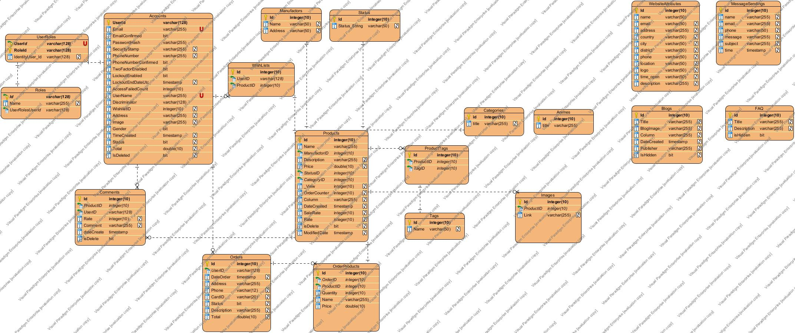

|  |  |  |
| --- | --- | --- |
| **Date: Sep 20, 2012** | **Prepared by Project Group 4**  **Team Leader:** | **Approved by**  **Mr. Ho Hoan Kiem** |
| **Signature** |  |  |

REVIEW 3

**INTERFACE DESIGN**

1. **Home Page**

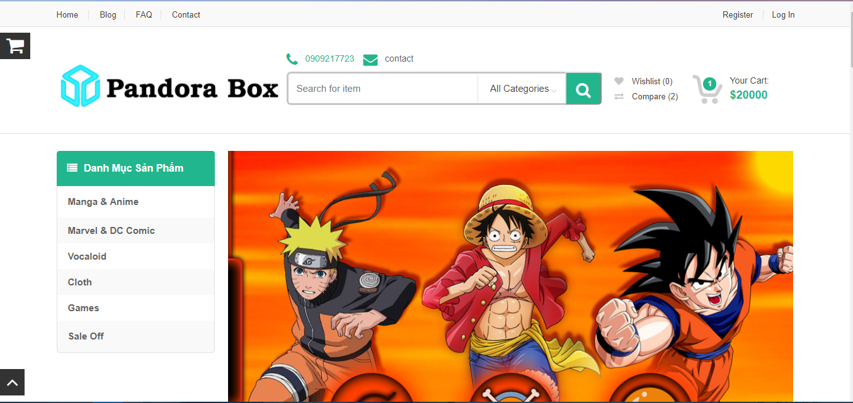

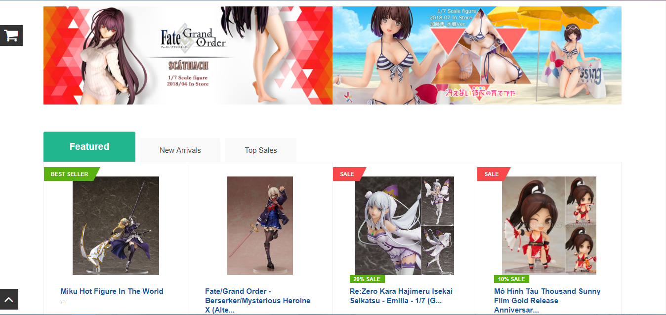

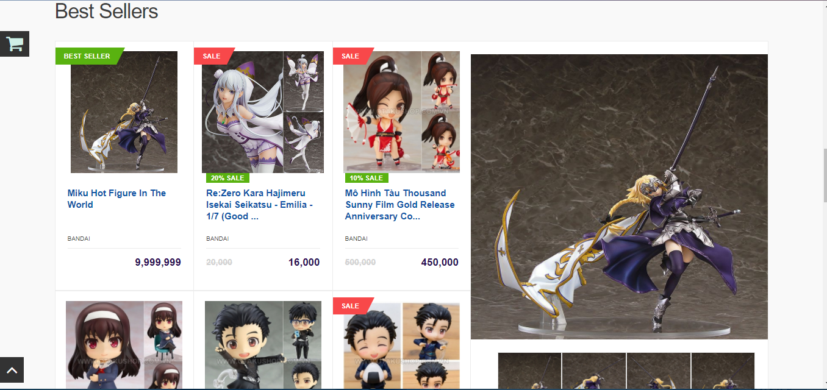

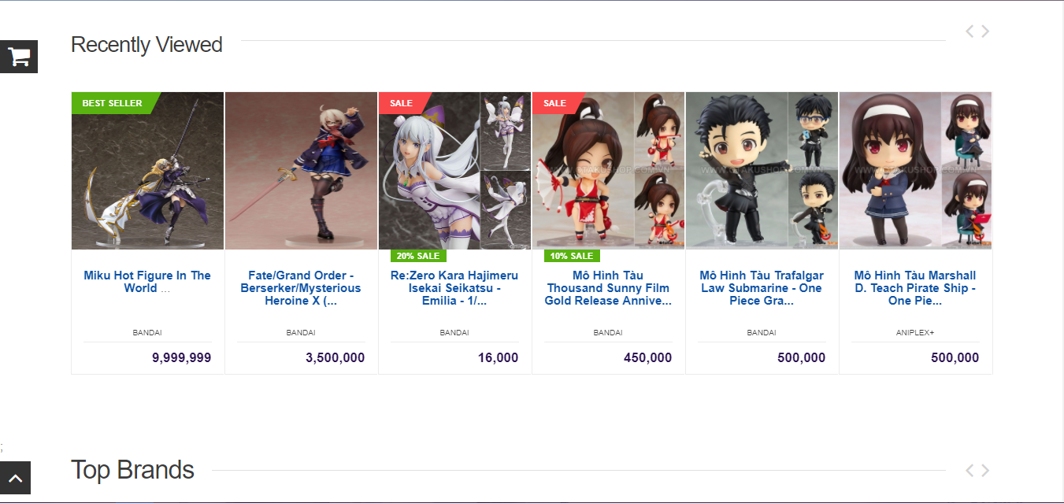

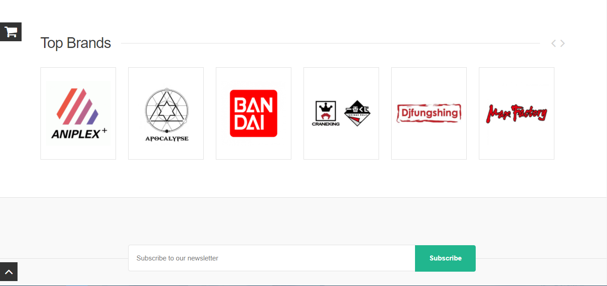

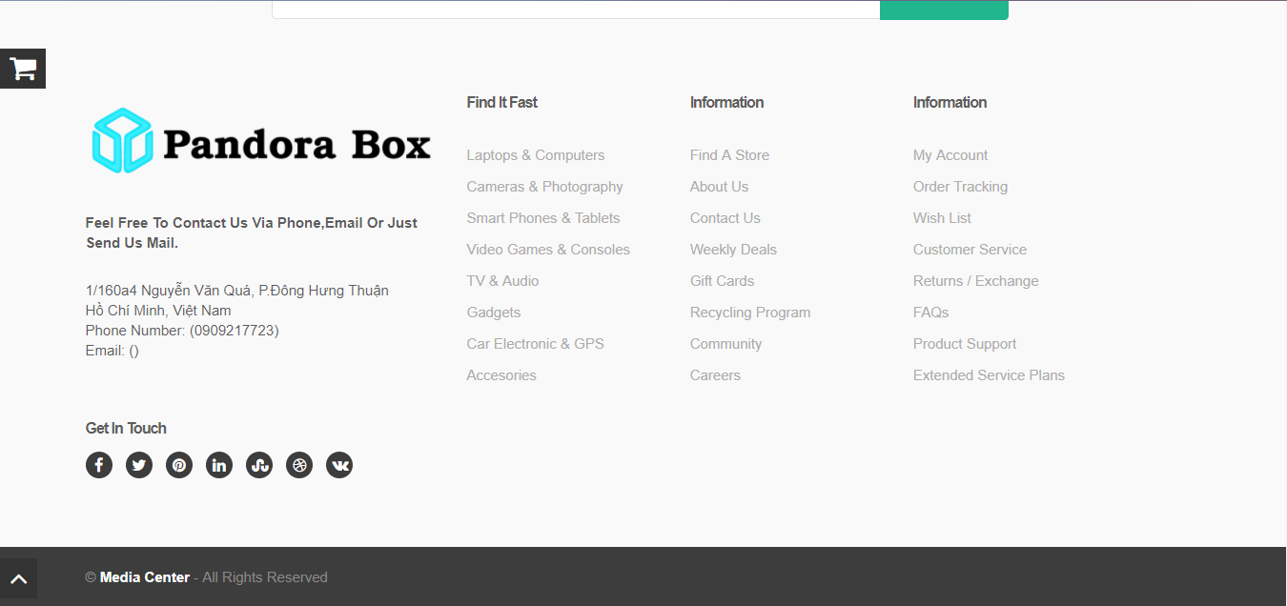

|  |  |  |  |  |  |
| --- | --- | --- | --- | --- | --- |
| **Name** | **Type** | **Event** | **Validation** | **Description** | **Status** |
| Home, Logo web | Hyperlink | Click |  | Move user to Home page |  |
| Blog, FAQ, Contact | Hyperlink | Click |  | Move user to Blog, FAQ, Contact page |  |
| Register | Hyperlink | Click |  | Move user to Register page |  |
| “Search for item”  Textfield | TextBox | Input | String | User input some keyword to find products. |  |
| Searching Button | Button | Click |  | When user click, system will move user to searching page with keyword user inputed on textbox |  |
| Wishlist link | Hyperlink | Click |  | Show total product in wishlist. When user click on it, system will move user to wishlist. |  |
| Compare link | Hyperlink | Click |  | Just a link without any action. May be update in the future. |  |
| Cart link, Cart icon | Hyperlink | Click |  | Show total product and total money in cart. When user click on it, system will move user to Cart page. |  |
| Category list | Hyperlink | Click |  | Click to search products by tag. |  |
| Arrow up icon | Hyperlink | Click |  | Move user to top page. |  |
| Figure name | Hyperlink | Click |  | Move user to detail page of product |  |
| “Add to cart” button | Button | Click |  | Add that product into cart. |  |
| “Add to wishlist” button | Button | Click |  | Add that product into wishlist |  |
| “Added” button | Button | Click |  | Remove that product out wishlist |  |
| Load more product | Hyperlink | Click |  | Move user to Searching page with all products. |  |
| Top Brand Logo | Hyperlink | Click |  | Move user to Searching page with products belong to that brand |  |

**2.Register Page:**

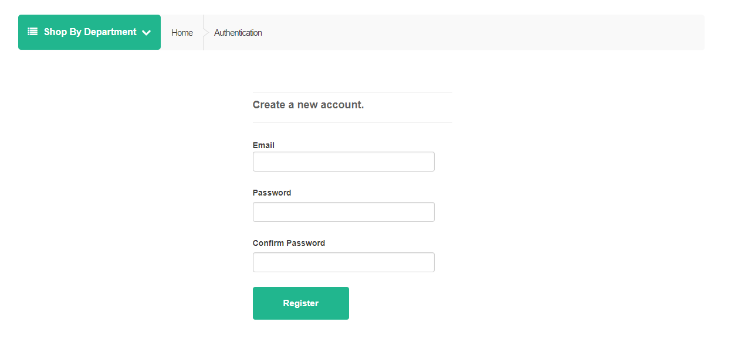

|  |  |  |  |  |  |
| --- | --- | --- | --- | --- | --- |
| Email TextBox | Text box | Input | String, Not Null | User must input their email into this text box. |  |
| Password TextBox | Text box | Input | String, Not Null | User must input their password into this text box. |  |
| Confirm Password TextBox | Text box | Input | String, Not Null | User must input password again into this text box. |  |
| Register Button | Button | Click |  | When user click on this button, system will create a new account for this user and move them to Home page. |  |

**3. Login Page:**

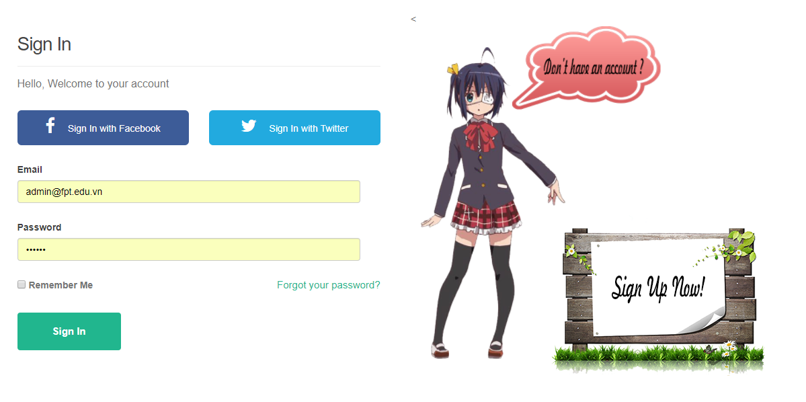

|  |  |  |  |  |  |
| --- | --- | --- | --- | --- | --- |
| Sign In with Facebook Button | Button | Click |  | Just a button without any action. May be update in the future. |  |
| Sign In with Twitter | Button | Click |  | Just a button without any action. May be update in the future. |  |
| Email Text box | Text box | Input | String, Not Null | User must input their email into this text box. |  |
| Password Text box | Text box | Input | String, Not Null | User must input their password into this text box. |  |
| Remember Me Check box | Check box | Check |  | Just a checkbox without any action. May be update in the future. |  |
| Forgot your password link | Hyperlink | Click |  | When user forgot their password, they can click on here to re-take their password by email. |  |
| Sign in button | Button | Click |  | When user click on here, system will check their email and password in database. If those are valid, system will move user to Home page with their account. |  |

**4: Searching Page:**

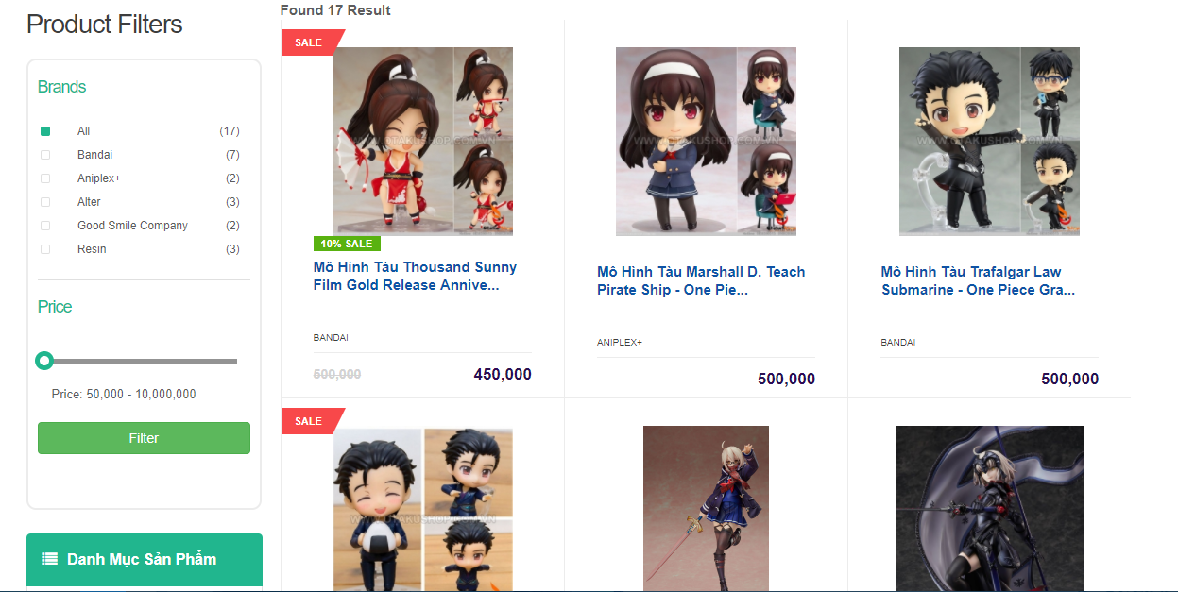

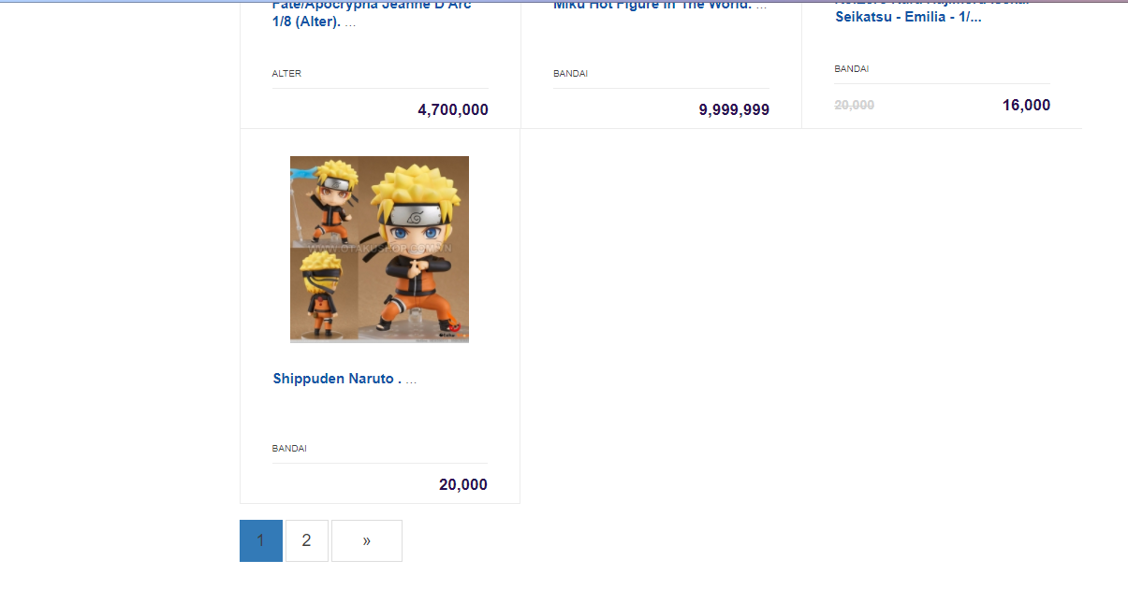

|  |  |  |  |  |
| --- | --- | --- | --- | --- |
| Brand list check box | Check box | Check |  | Users check on brand that they want to filter. |
| Price slider | Slider | Move |  | Users move that slider to choose price that they want to filter. |
| Filter Button | Button | Click |  | When users click on this button, system will filter their products is showing on view and return products havebrand and suitable price. |
| “Add to cart” button | Button | Click |  | Add that product into cart. |
| “Add to wishlist” button | Button | Click |  | Add that product into wishlist |
| “Added” button | Button | Click |  | Remove that product out wishlist |
| Pager list | Pager | Click |  | List of pager of this page. Each page have max products are 18. |

**5. Product Detail Page:**

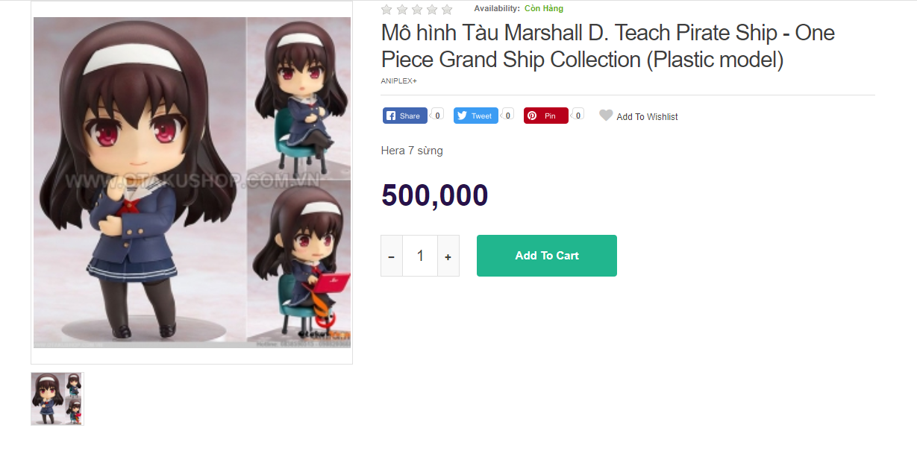

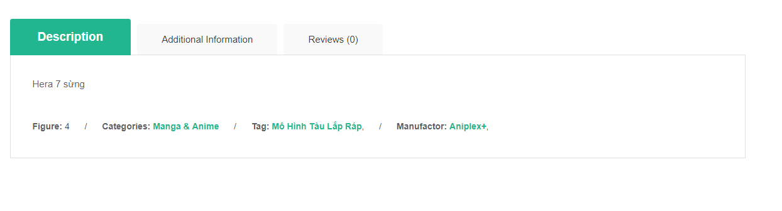

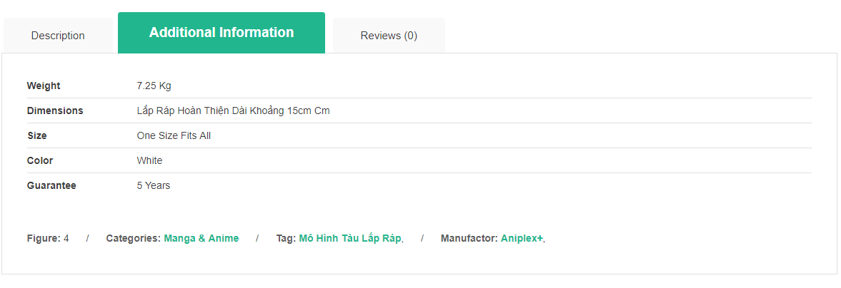

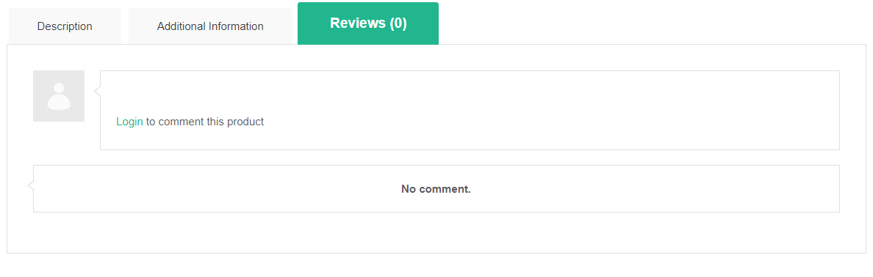

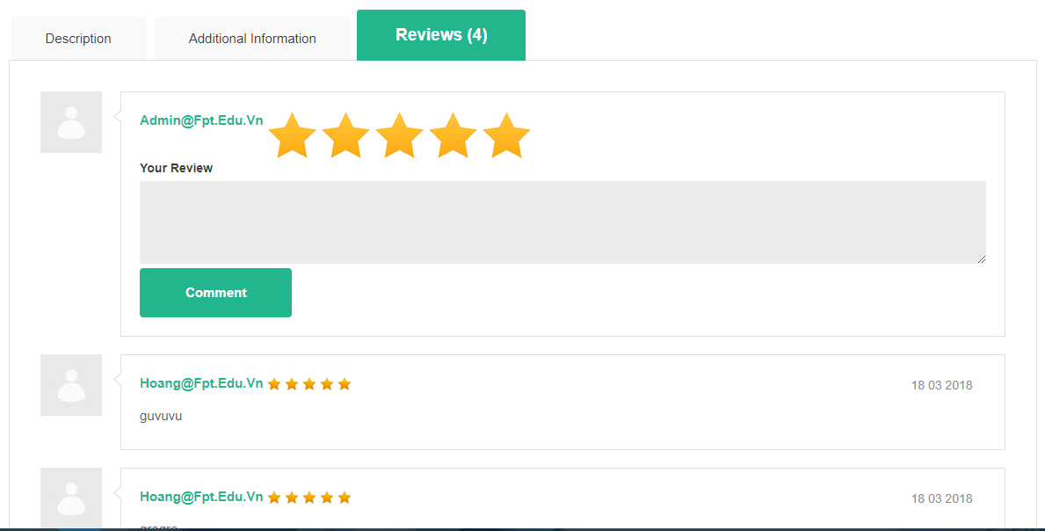

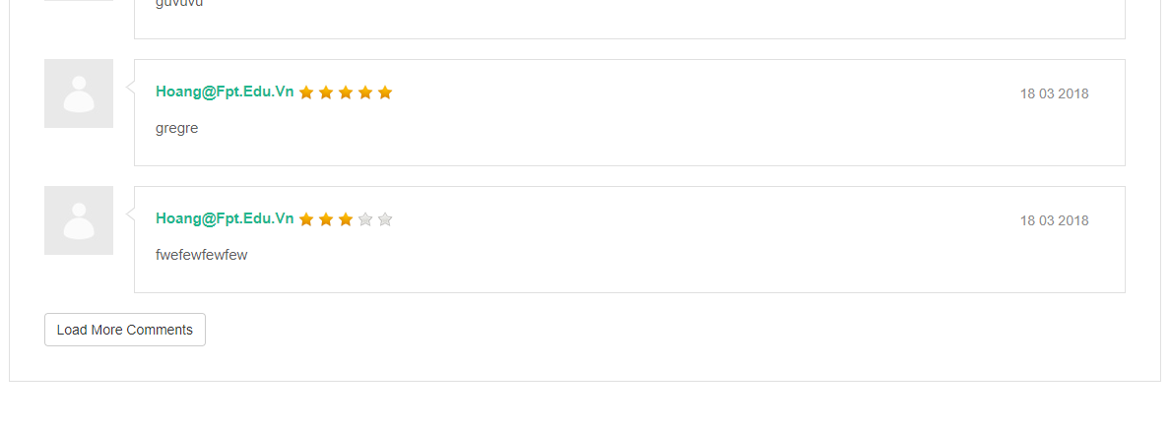

|  |  |  |  |  |
| --- | --- | --- | --- | --- |
| Product Image | Image |  |  | Show product image to users. |
| Product Thumbail(s) | Image | Select |  | Users can select on thumbail to change big image of product above. |
| Product’s Rate Star | Star |  | Readonly | Displayaverage star was commented by users. |
| Availability status | Text |  | Readonly | Display product status. |
| Facebook, Twitter, Pinterest button | Button | Click |  | Just a button without any action. May be update in the future. |
| “Add to wishlist” button | Hyperlink | Click |  | Add that product into wishlist |
| Product’s quantity counter | Number choice | Click | int | Click to choose how many product users want to buy. |
| “Add to cart” button | Button | Click |  | Add this product into cart. |
| Category link | Hyperlink | Click |  | Move user to Searching page with product in this category. |
| Tag link | Hyperlink | Click |  | Move user to Searching page with product in this tag. |
| “Add to wishlist” button | Hyperlink | Click |  | Add that product into wishlist |
| User rate star | Stars | Click |  | Users choose how many stars they want on this product. |
| User review | Text box | Input |  | Users input their thinking about of product. |
| Comment button | Button | Click |  | Send their comment to server. After moment few later, system will reload Review tab pane. |
| Other user rate star | Stars |  | Readonly | Other rate star was commented before. |
| Load more comment button | Button | Click |  | Load more comments of this product. |

**6.Wishlist Page:**

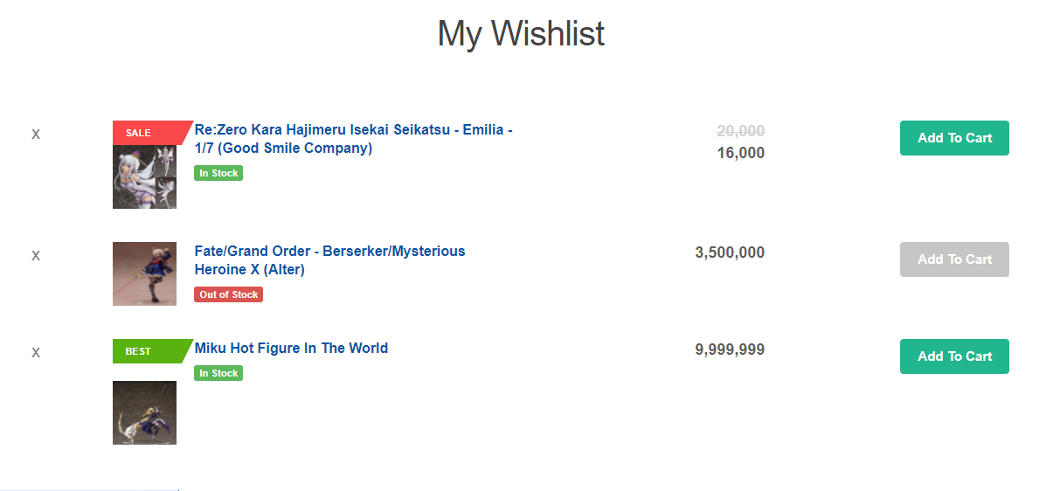

|  |  |  |  |  |
| --- | --- | --- | --- | --- |
| “X” button | Button | Click |  | Remove this product out wishlist. |
| Product name | Hyperlink | Click |  | Move user to Product Detail Page of this product. |
| “Add to cart” Button | Button | Click |  | Add this product into cart. |

**7.Cart Page:**

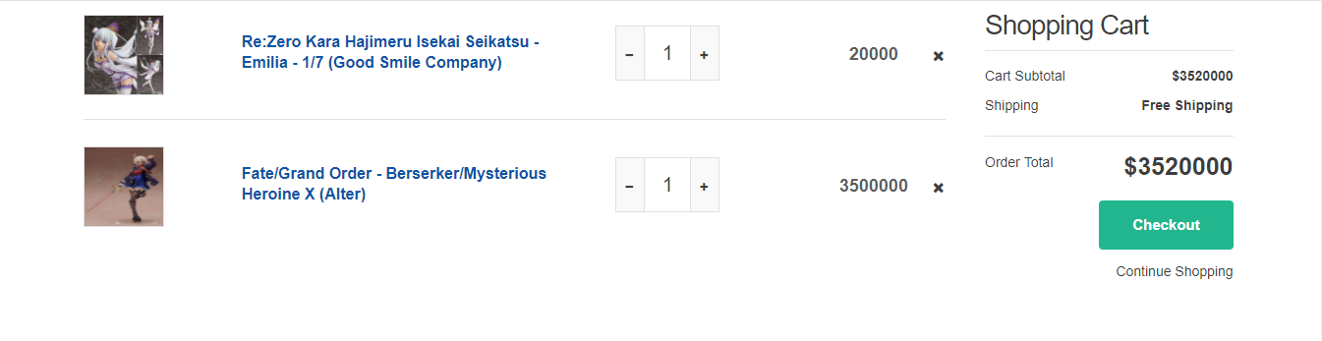

|  |  |  |  |  |
| --- | --- | --- | --- | --- |
| Product name | Hyperlink | Click |  | Move user to Product Detail Page of this product. |
| Product’s quantity counter | Number choice | Click | int | Click to choose how many product users want to buy. |
| “X” button | Button | Click |  | Remove this product out cart. |
| Checkout button | Button | Click |  | Checkout this cart. When user click on this button, system will excute action and move user to Home page with a message successful. |

**9.Blog Page:**

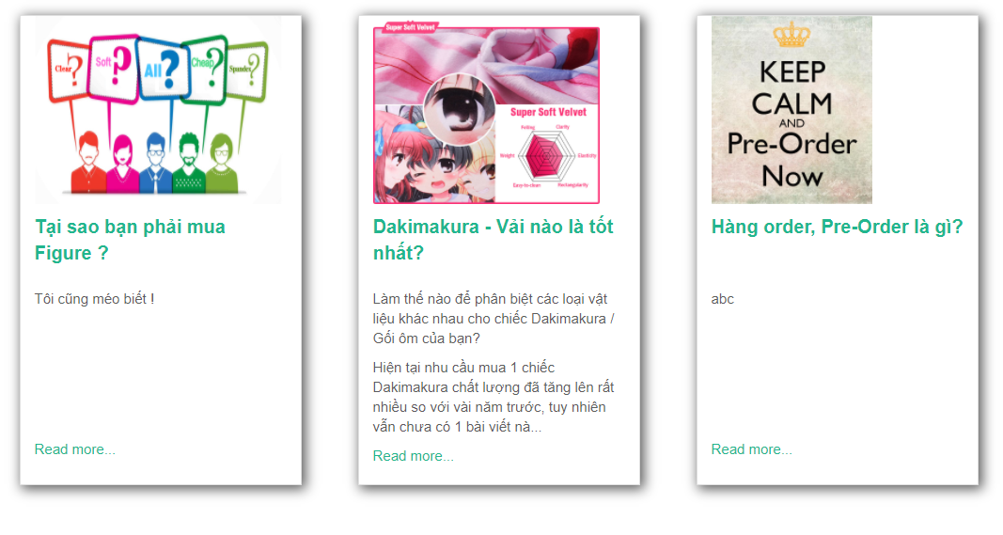

|  |  |  |  |  |
| --- | --- | --- | --- | --- |
| Blog title | Hyperlink | Click |  | Move user to this blog index to see more information. |
| “Read more” link | Hyperlink | Click |  | The same with Blog title. |

**10.FAQ Page:**

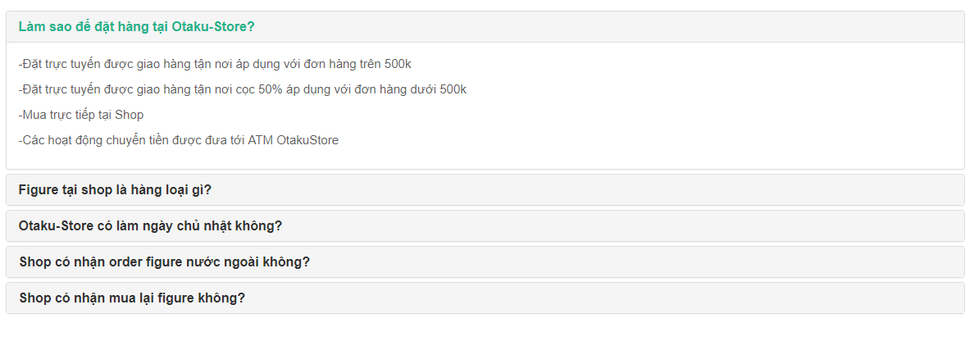

|  |  |  |  |  |
| --- | --- | --- | --- | --- |
| FAQ title | Hyperlink | Click |  | Show all description about this FAQ. |

**11.Contact Page:**

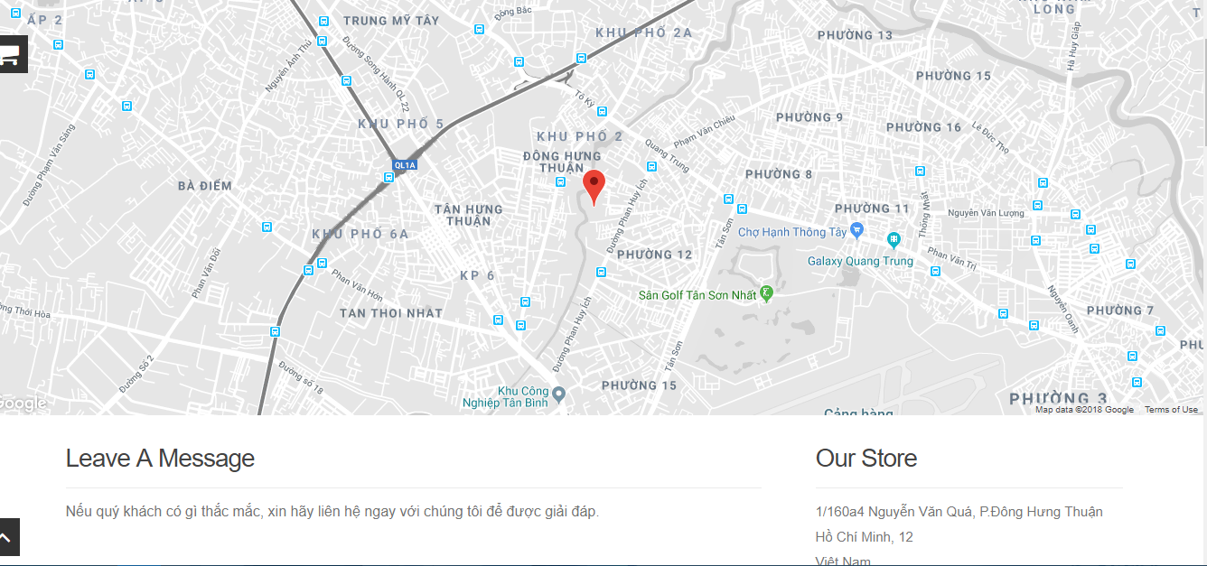

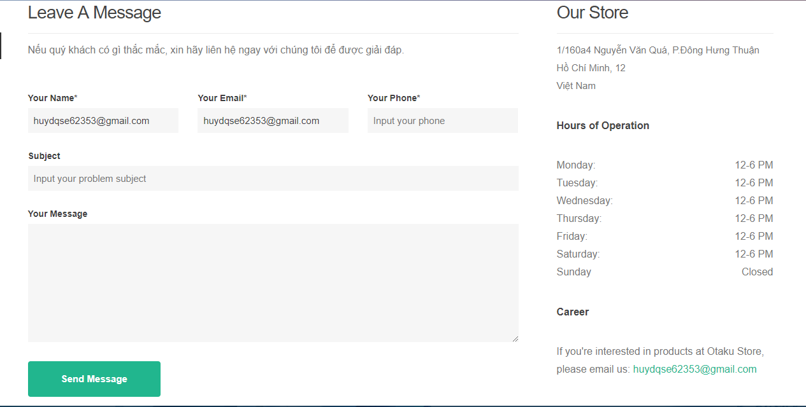

|  |  |  |  |  |
| --- | --- | --- | --- | --- |
| Google Map | Map | Click |  | This map used to see the easiest way to go to own store. |
| Your Name Textbox | TextBox | Input | String, Not null | Input user’s name in this text box. |
| Your Email Textbox | TextBox | Input | String, Not null | Input user’s email in this text box. |
| Your Phone Textbox | TextBox | Input | String, Not null | Input user’s phone number in this text box. |
| Subject Textbox | TextBox | Input | String, Not null | Input user’s problem in this text box. |
| Message Textbox | TextBox | Input | String, Not null | Input user’s message want to send to website in this text box. |
| Send Message Button | Button | Click |  | When user click on this button, system will check valid all information in this form. If all are valid, system will insert this form into database and move user to Home page with a successful message. |

**12.Edit Profile Page:**

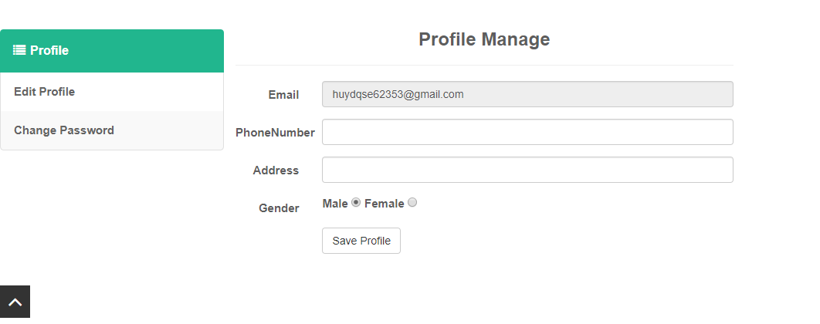

|  |  |  |  |  |
| --- | --- | --- | --- | --- |
| Edit Profile Menu | Hyperlink | Click |  | Move user to Edit Profile Page. |
| Change Password Menu | Hyperlink | Click |  | Move user to Change Password Page. |
| Email Textbox | TextBox |  | Readonly | Show user’s email. |
| Phone number Textbox | TextBox | Input | String | Input user’s phone number in this text box. |
| Address Textbox | TextBox | Input | String | Input user’s address in this text box. |
| Gender radio check box | Radio | Check |  | Check to choose user’s gender. |
| Save Profile Button | Button | Click |  | Save user’s profile in database. |

**13.Change Password Page:**

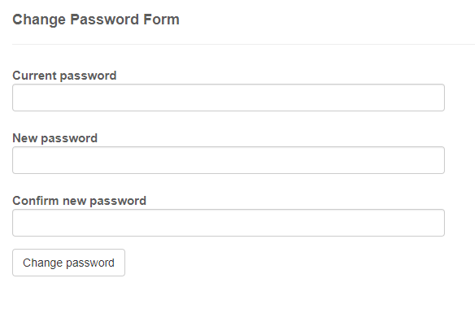

|  |  |  |  |  |
| --- | --- | --- | --- | --- |
| Current Password Textbox | TextBox | Input | String, Not null | Input user’s current password in this text box. |
| New Password Textbox | TextBox | Input | String, Not null | Input user’s new password want to change in this text box. |
| Confirm New Password Textbox | TextBox | Input | String, Not null | Input user’s new password again to check in this text box. |
| Change password Button | Button | Click |  | Change user’s password. |

**14.Admin Index Page:**

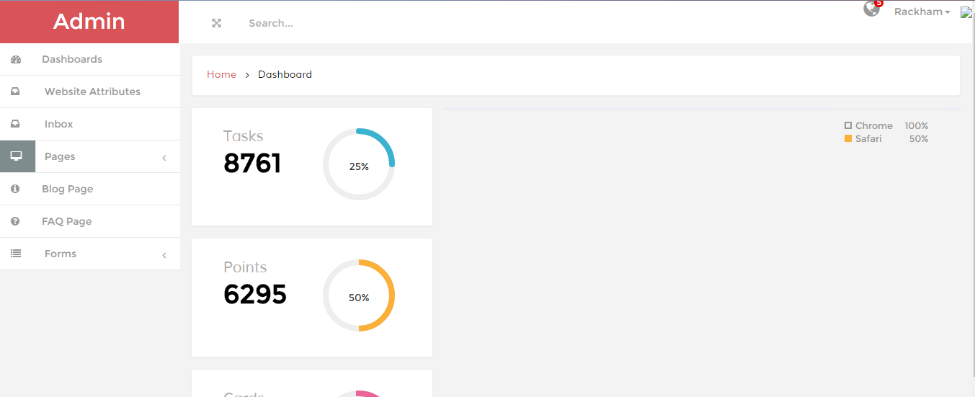

|  |  |  |  |  |
| --- | --- | --- | --- | --- |
| Dashboards menu | Hyperlink | Click |  | Move user to Admin Index Page. |
| Website Attributes menu | Hyperlink | Click |  | Move user to Website Attributes Page. |
| Inbox menu | Hyperlink | Click |  | Move user to Message Sending Page. |
| Page menu | Hyperlink | Click |  | Show more options include: Blog Page, FAQ Page. |
| Blog Page menu | Hyperlink | Click |  | Move user to Blog Management Page. |
| FAQ Page menu | Hyperlink | Click |  | Move user to FAQ Management Page. |
| Forms menu | Hyperlink | Click |  | Show more options include: Products Page, Users Page. |
| Product Management Page menu | Hyperlink | Click |  | Move user to Product Management Page. |
| User Management Page menu | Hyperlink | Click |  | Move user to User Management Page. |
| Searching Text Box | Textbox | Input | String | Just a textbox without any action. May be update in the future. |
| Global Notification and Edit menu | Hyperlink | Click |  | Just a link without any action. May be update in the future. |
| Pie Chart | Chart |  |  | Just a chart without any action. May be update in the future. |

**15.Website Attributes Page:**

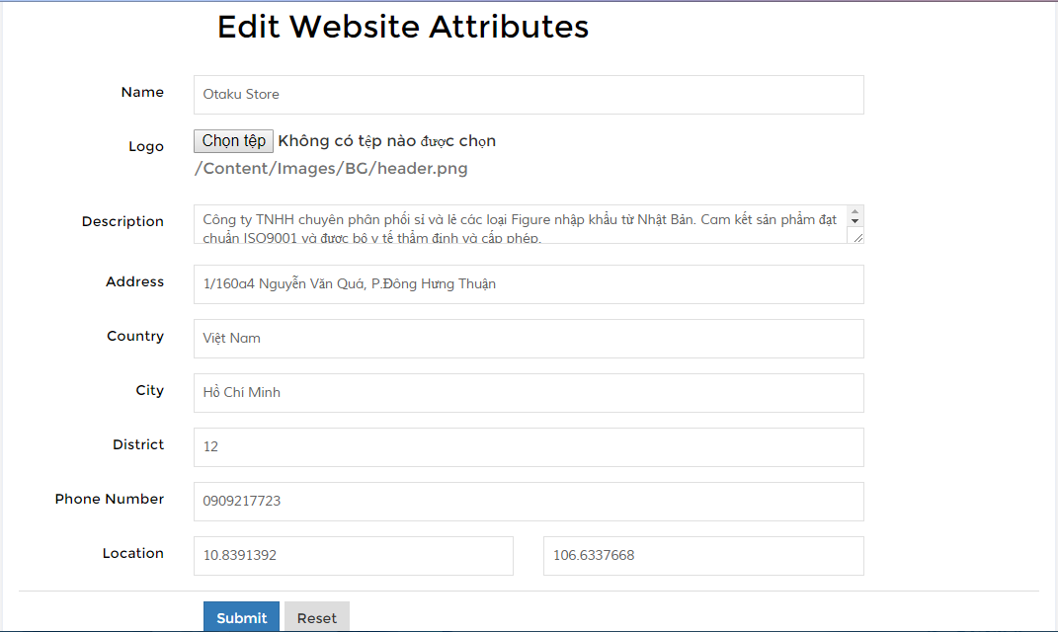

|  |  |  |  |  |
| --- | --- | --- | --- | --- |
| Name Textbox | TextBox | Input | String, Not null | Input name of website. |
| Logo Website | Image | Input |  | Choose logo for this website. |
| Description | TextBox | Input | String | Input description of website |
| Address Textbox | TextBox | Input | String, Not null | Input address of website. |
| Country Textbox | TextBox | Input | String, Not null | Input country of website. |
| City Textbox | TextBox | Input | String, Not null | Input city of website. |
| District Textbox | TextBox | Input | String, Not null | Input district of website. |
| Phone number Textbox | TextBox | Input | String, Not null | Input phone number of website. |
| Location Textbox | TextBox | Input | String, Not null | Input x-cor and y-cor of website. |
| Submit button | Button | Click |  | When admin click on this button, system will save all information into database and notify a successful message. |
| Reset button | Button | Click |  | Reset all text box |

**16.Website Attributes Page:**

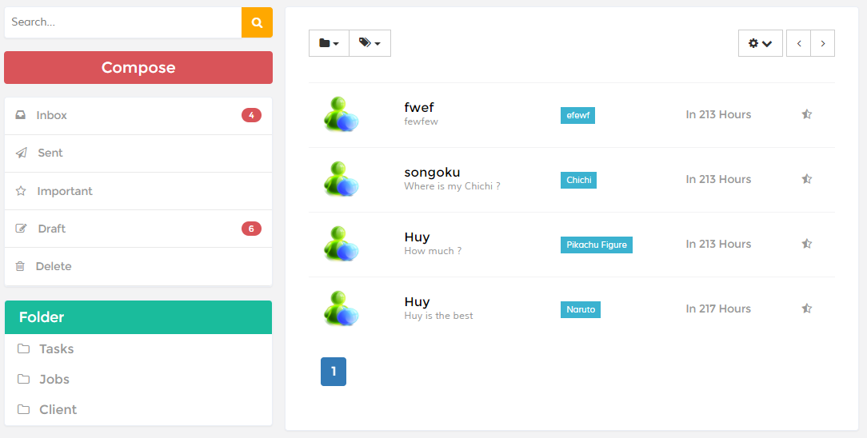

|  |  |  |  |  |
| --- | --- | --- | --- | --- |
| Inbox menu | Menu | Click |  | Show all message sending from users. |
| Sent, Important, Draft, Delete, Tasks, Jobs, Client menu | Menu |  |  | Just a menu without any action. May be update in the future. |

**16.Blog Management Page:**

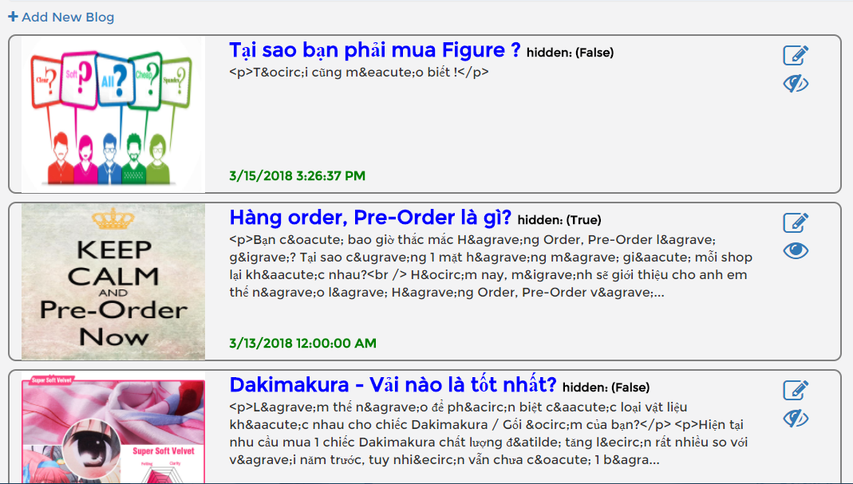

|  |  |  |  |  |
| --- | --- | --- | --- | --- |
| Edit icon | Hyperlink | Click |  | Move admin to Blog Info Page. |
| Hidden icon | Hyperlink | Click |  | Set IsHidden for this blog and reload page. This icon also set this blog is not hidden. |
| Add new blog hyperlink | Hyperlink | Click |  | Move admin to New Blog Page. |

**17.Blog Info Page and Add New Blog:**

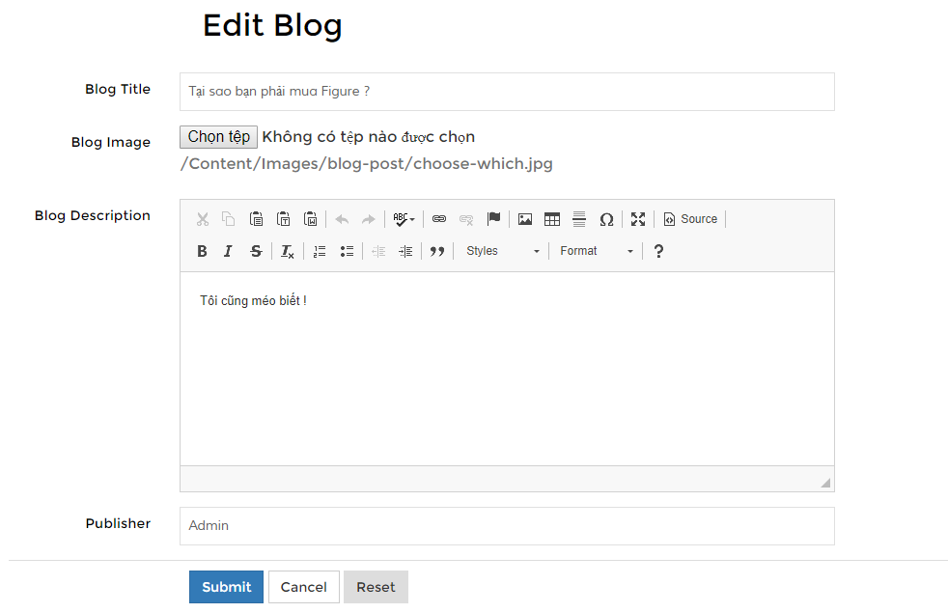

|  |  |  |  |  |
| --- | --- | --- | --- | --- |
| Blog Title Textbox | TextBox | Input | String, Not null | Input blog’s title in this text box |
| Blog Image Input | Image | Input |  | Choose image banner for this blog. |
| Blog Description Editor | CKEditor | Input | Html String | Input content of this blog includes: text, image, font-style,… |
| Publisher Textbox | TextBox | Input | String, Readonly | Set defaul publisher is admin. |
| Submit button | Button | Click |  | When admin click on this button, system will save all information into database and notify a successful message. |
| Reset button | Button | Click |  | Reset all text box |

**18.FAQ Management Page:**

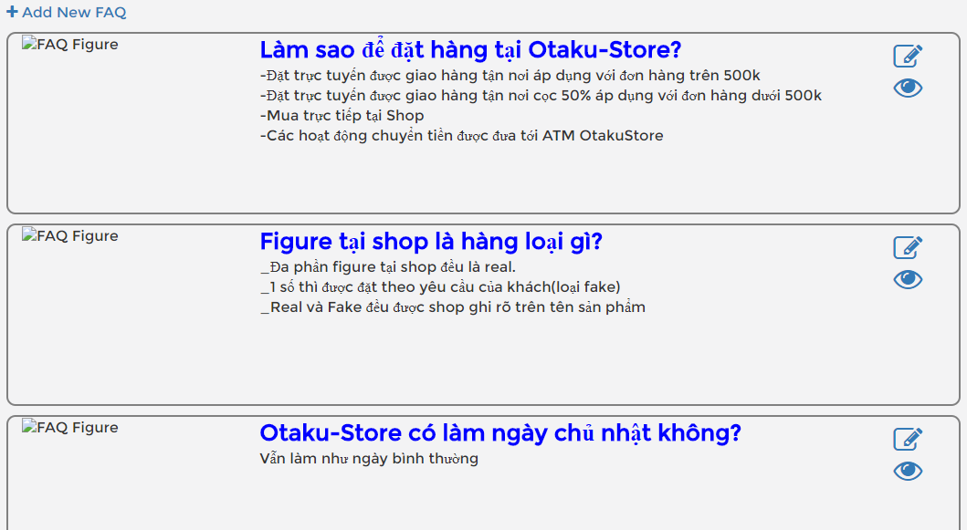

|  |  |  |  |  |
| --- | --- | --- | --- | --- |
| Edit icon | Hyperlink | Click |  | Move admin to FAQ Info Page. |
| Hidden icon | Hyperlink | Click |  | Set IsHidden for this blog and reload page. This icon also set this blog is not hidden. |
| Add new FAQhyperlink | Hyperlink | Click |  | Move admin to New FAQ Page. |

**19.FAQ Info Page and Add New FAQ Page:**

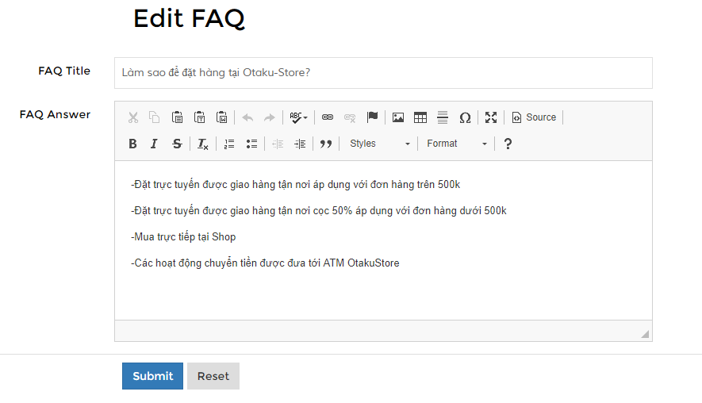

|  |  |  |  |  |
| --- | --- | --- | --- | --- |
| FAQ Title Textbox | TextBox | Input | String, Not null | Input FAQ’stitle in this text box |
| FAQ Description Editor | CKEditor | Input | Html String | Input content of this FAQ includes: text, image, font-style,… |
| Submit button | Button | Click |  | When admin click on this button, system will save all information into database and notify a successful message. |
| Reset button | Button | Click |  | Reset all text box |

**19.Product Management Page:**

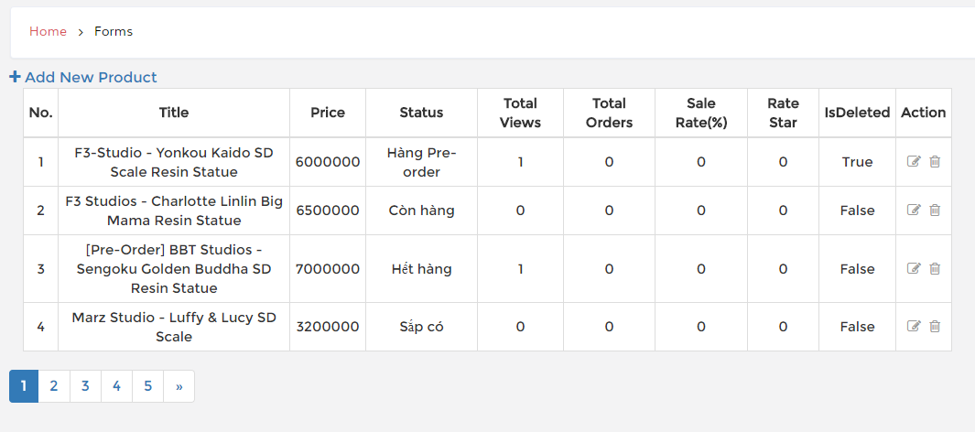

|  |  |  |  |  |
| --- | --- | --- | --- | --- |
| Edit icon | Hyperlink | Click |  | Move admin to Product Info Page. |
| Delete icon | Hyperlink | Click |  | Set IsDelete for this product and reload page. This icon also set this product is not delete. |
| Add new product hyperlink | Hyperlink | Click |  | Move admin to New Product Page. |

**19.Product Info Page and Add New Product Page:**

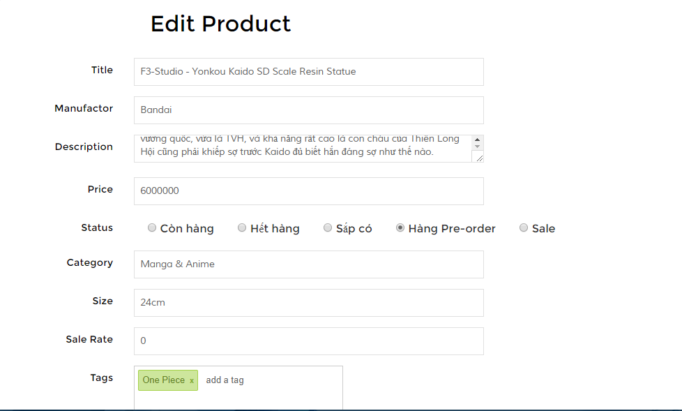

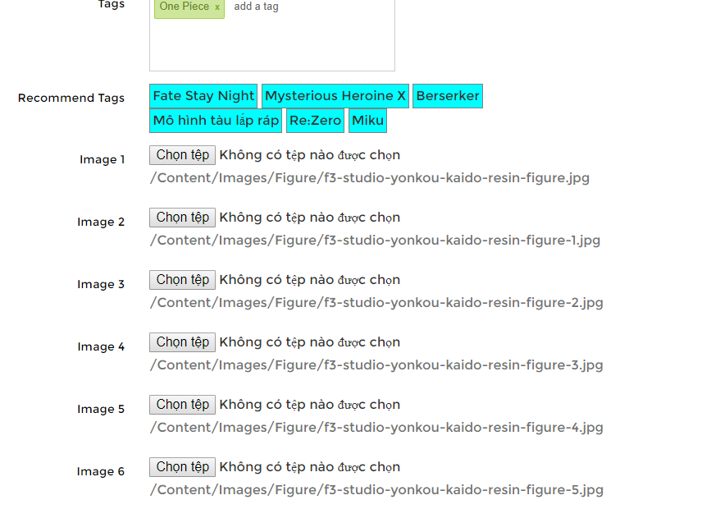

|  |  |  |  |  |
| --- | --- | --- | --- | --- |
| Title Textbox | TextBox | Input | String, Not null | Input Title of product. |
| Manufactor Seleted Box | Selected Box | Select |  | Select brand for this product. |
| Description | TextBox | Input | String | Input description of product. |
| Price Textbox | TextBox | Input | int, Not null | Input price of product. |
| Status radio | Radio | Select |  | Select status for this product. |
| Category Seleted Box | Seleted Box | Select |  | Select Category for this product. |
| Size TextBox | TextBox | Input | String | Input size of product. |
| Sale Rate | TextBox | Input | Int, (Null or Not null) | This textbox can be input if Sale Status is selected.  If any status except Sale Status is selected, this textbox will be set readonly and value equal 0. |
| Tags Input | TextBox | Input | Tag | Input tags for this product. |
| Recommend Tags Input | TextBox | Input | Tag | This textbox will show some popular tags to recommend admin. This function will descrease some tags have the same meaning but different string. |
| ImagesInput | Image | Input |  | Choose images for this product. (Max images are 6). |
| Submit button | Button | Click |  | When admin click on this button, system will save all information into database and notify a successful message. |
| Reset button | Button | Click |  | Reset all text box |

**20.User Management Page:**

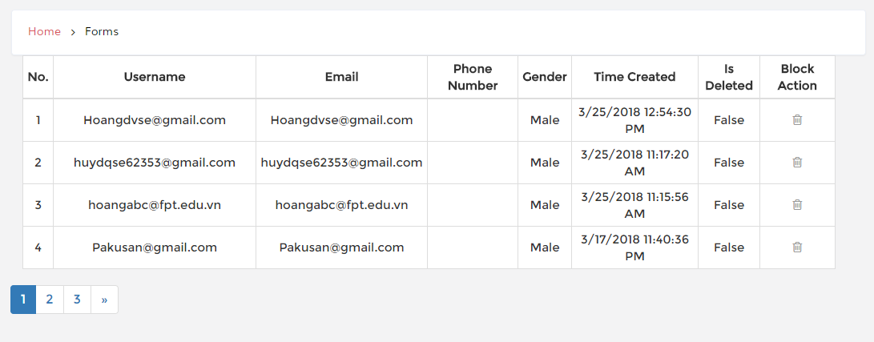

|  |  |  |  |  |
| --- | --- | --- | --- | --- |
| Block user icon | Hyperlink | Click |  | Set IsDeleted or Not for userimmediately and reload page with a successful message. |

**TASK SHEET**

|  |  |  |  |  |  |  |
| --- | --- | --- | --- | --- | --- | --- |
| **Project Group …** | | **Project Title**  **Otaku Store (Figure Shop)** | | **Date of Preparation** | | **Activity Plan Prepared by**  **all people in group** |
| **No** | **Task Title** | | **Planned Start Date** | **Planned Completed Date** | **Team Mate Names** | **Status** |
| 1 | Build Source 3 layer | | Feb 20, 2018 | Mar 25, 2018 | **Hoang** | Done |
| 2 | Authorize,register,login,logout | | Done |
| 3 | editProfile,changePassword,Forget Password | | Done |
| 4 | ProductDetail,Comment rate Product,WishList | | Done |
| 5 | Searching Product | | Done |
| 6 | Handler exception page | | Done |
| 7 | Change some font end and action of index home,design edit profile font end | | Done |
| 6 | Product Management Page and functions. | | **Đổng Huy** | Done |
| 7 | User Management Page and functions. | | Done |
| 8 | All Blogs, FAQs Page and functions. | | Done |
| 9 | Contact Page (User) and Message Sending Page (Admin) and functions. | | Done |
| 10 | Website Attributes Page and functions. | | Done |
| 11 | Button “Add to wishlist” call Ajax and Frond-end effects. | | Done |
| 12 | Display all products and website attributes on Home Page (User). | | Done |
| 13 | Filter by brand and price in Searching Page. | | Done |
| 14 | Cart Page and funtions. | | **Bùi Huy** | Done |
| 15 | CheckOut Page and funtions. | | Done |
| 16 | Searching Product | | Done |
| 17 | Cart-Review on _SearchMain | | Done |
| 18 | Add to cart Button, both from product page and index | | Done |
| 19 | Design Database | |  |  | **All people in group** | Done |
|  |  | |  |  |  |  |

|  |  |  |
| --- | --- | --- |
| **Date: Oct 10, 2012** | **Prepared by Project Group 4**  **Team Leader:** | **Approved by**  **Mr. Ho Hoan Kiem** |
| **Signature** |  |  |